**PennWest Military and Veteran Student Success Database**

Final Design Specification

Andrew Evans

Jenna Guffy

Evan Reinheimer

**Introduction**

For the CMIS 4900 Senior Capstone, The Regulars have taken on the task of the creation of an application and included database that would assist with certifications for military students using benefits provided by the United States Department of Veterans Affairs.

The proposed database would store student’s information with categories for student type, VA aid type, major, number of credit hours registered each semester, graduation date, GI Bill benefit balance, and certification completion for each semester, and a user interface for students to have access to their information in real time. This system would automate email reminders to the students when forms are due, so it will be capable of interacting with the email server, as well as include information from the database about the student’s remaining benefits. When a student’s benefit runs out, based on their student type in the database, an email would be sent out with ideas for additional funding resources that they qualify for, such as grants or scholarships.

**PennWest Financial Aid Veteran’s Database Charter**

1. **Abstract**

The purpose of the project is the creation of a database and accompanying application that would assist with certification for military students using benefits provided by the United States Department of Veterans Affairs. This will assist those who are currently forced to navigate the system and make the work of the financial aid office easier. The goal will be met when the system is able to effectively manage the financial aid for those who qualify for aid through Veterans Affairs.

1. **Anticipated Completion**

The project should be completed by April 28th, 2025.

1. **Approved Budget**

The current budget is: **$0**

This budget is subject to change.

1. **Team Members and Roles**

Jenna Guffy - Project Lead

Andrew Evans - Analyst

Evan Reinheimer - Resource/Functional Manager

**Member Sign-Off:**

**X** Evan Reinheimer

**X Jenna Guffy**

**X Andrew Evans**

**Project Scope Statement**

**Project Title:** PennWest Military and Veteran Student Success Database

1. **Problem Description**

The Military and Veteran Student Success department at PennWest is overburdened with information pertaining to students that use benefits provided by the U. S. Department of Veteran’s Affairs (henceforth referred to as “the VA”), but with no real centralized way to track and update the information. Students using VA benefits have to certify monthly that they are attending full time classes and submit a benefits renewal on the VA website before the beginning of each semester. The Military and Veteran Student Success department has to track that they have received the benefits renewal before each semester begins and if they have not received it they have to reach out to the students who are missing the renewal. There is no automated system to send out reminder emails to students that are required to certify and there is no centralized way for these students to access the amount of aid they have left.

These inefficiencies lead to poor tracking of student certifications and require manual communications with students as reminders to renew. The staff must also keep record of who they have contacted, but they only way that they currently have to accomplish keeping a log is to save the sent emails since there is not a centralized log for student communications. This process is arduous for staff and can make certifying confusing and stressful for students.

**2.0 Project Objectives**

* + Develop a database to track VA information for eligible students
* Implement automated communication system for student reminders
* Allow filtering and reporting for different student situations and aid types
  + Filtering for months/days of aid left
  + Filtering for GI Bill (Post 9/11 or Montgomery), VR&E aid, National Guard Tuition assistance, etc.
* Provide a secure website for students to access aid balance and pending tasks
  + Potentially add access to the interface from student’s myPennWest account
* Develop a user-friendly interface for Military and Veteran Student Success staff to manage student information

**3.0 Anticipated Business Benefits**

This system will increase the efficiency of the department’s operations and reduce stress of the staff during the months and weeks leading up to each new semester by tracking the students benefits automatically, reminding students with automated communications instead of manually generated communications, and providing the Military and Veteran Success staff with filtering and reporting abilities in a centralized database specifically for students using VA benefits. This project will also lead to improved student satisfaction and retention rates due to the enhanced certification experience, which includes comprehensive record keeping and updates for their benefits and VA certifications. These students won’t have to keep track of additional steps for securing their benefits each semester, because this project will assist the department in providing the reminders. With the alleviation of stress, we anticipate that the students will feel valued and important to the PennWest community and will lead to an increase in recommendations of the institution to their acquaintances or community members. This will create a positive community view of PennWest as a veteran friendly organization, which can potentially increase enrollment owing to positive word-of-mouth recommendations.

**4.0 System Capabilities**

This system will satisfy the above-mentioned business benefits by:

* Sending automated reminder emails to students two months before the new semester, and then each week for four weeks leading up to the semester start.
* Having email templates available for the staff to quickly send updates to students.
* Tracking the certifications in a concise and easily accessible way so that the Military and Student Success staff can quickly assess who still needs to complete certifications.
* Send out automated emails with potential resources for additional aid to any student that has exhausted the current aid
* Provide a way for students to access their aid balance and any tasks that need to be completed.
* Monitoring VA aid balances for each student and providing a way for the Military and Student Success department to quickly filter students by type.
* Robust reporting that includes students who have certified with their names, IDs, contact information, and aid type included.
  + The ability to schedule emails based on report results.
  + These reports do not contain historical data, just certifying information for outstanding certifications.

**5.0 Integration Requirements**

//placeholder until meeting with IT

**6.0 Stakeholder Roles**

This application will be used by the employees in Military and Veteran Student Success. This office is comprised of the Director and Assistant Director, in which the Assistant Director is the School Certifying Official. The Assistant Director will primarily access, input, and modify student’s information, while the Director may occasionally access or update the information.

**7.0 Project Scope**

**7.1 In Scope**

This project is to develop a database for VA benefit information for PennWest Students with an included staff interface for managing student information. We will implement an automated email system for reminders and notifications of various types that can be modified by staff in the financial aid department. These email reminders will be in selectable template form so that the certifying officials can access and send them with haste. The emails can be scheduled to auto send at specific intervals to coincide with start of semesters. Reporting tools will be built in so that the staff has easy access to student information by aid type, aid balance, or certification status. Pending IT approval, this would also include a student portal to access the VA benefit information that PennWest monitors for enrollment.

**7.2 Out of Scope**

This will not include direct integration to the VA website or any additional monthly certification that the student has to complete directly through the VA. This project will not track or modify any existing PennWest financial aid systems and will not provide management of financial aid that is separate from the VA such as state or federal grants. This will not keep track of FAFSA information for students. Financial Aid Staff will need to enter benefit information for each student into the database as it is received from the VA, the system cannot automatically keep record of the remaining VA benefits since there isn’t integration with the VA website, but it can store the information for reporting and reminder purposes.

**8.0 Risk Analysis**

**8.1 Potential Risks**

We would have to construct a database to store all of the student’s information along with an interface and options for automated or pushed out pre-drafted emails. The only risks would be associated with direct student access to the database to monitor their information. This may be difficult to achieve as integration with existing PennWest systems could present challenges regarding data security and privacy concerns. Due to these concerns, the IT department may not approve student access to the system.

To mitigate risks, we will be sure to initiate early engagement with the IT department to address any concerns about the project. We will conduct thorough testing of system integrations at frequent intervals and implement robust security measures. FERPA covers VA benefits as well, so we will implement a login for school certifying officials. We will integrate robust security in the PennWest system with the guidance and permission of the IT department. //Need more security and student access info from IT

**9.0 Constraints and Limitations**

We will be limited in that we cannot directly connect to the VA’s website for the students to complete monthly certifications directly from the PennWest website, they will still have to complete monthly certifications through the VA, we will just be able to send reminders. We will also be limited to times that the financial aid office is not overburdened for collecting stakeholder information, user stories, and implementation when the time comes.

As a team, we certainly have the tools and abilities to construct a database that can generate reports and support querying and searching. I also feel that we have adequate scheduling resources for completion of the project, as it is uncomplicated, and we will have three individuals working for several months.

**10.0 Timeline and Resources**

The estimated project duration will be from September 24, 2024, through April 15, 2025. We will have three team members with database development and project management skills working part time on the project throughout the duration. The key stakeholders are the Financial Aid Department, the IT Department, and the student Veterans.

**11.0 Training and Support**

A detailed user manual will be provided upon launch. Developers will also be available in the weeks before deployment to answer questions while staff familiarizes themselves with the system and its capabilities.

**12.0 Success Criteria**

* 90% reduction in manual communication efforts regarding VA certifications
* 95% of students utilizing VA benefits will complete certifications after implementation
* Military and Student Success staff report 75% improvement in efficiency for VA benefit management
* Student satisfaction with PennWest VA benefit process improves by 40% (based on surveys)

**User Stories**

**Scenario**: A database for the Military and Veteran Student Success department to use for students that are accessing VA benefits.

**Persona:** School Certifying Official in the Military and Veteran Student Success Department

**Stories:**

**Priority #1:**

* As the Director of Military and Veteran Student Success, I want to manage user access and permissions within the VA benefits database so that I can ensure data security and appropriate feature access for my team.
  + **Acceptance Criteria**
    - Given I am logged in as a manager, I can create new user accounts for department staff.
    - Given I am managing a user account, I can assign or modify user accounts and their system permissions.

**Priority #2:**

* As the Assistant Director, I want the ability to access a report of students who have not completed VA certification for the current or upcoming semester so that I can ensure all eligible students are accessing their aid.
  + **Acceptance Criteria:**
    - Given that I have accessed the database, I should be able to access reporting options
    - Given that I have accessed the reporting options, I should be able to generate a report that shows which students have certified for the upcoming semester on the VA website, including their names, student IDs, and contact information and aid type
    - Given that I have accessed the reporting options, I should be able to schedule emails to the chosen students based on the results of the report
    - Given that I have accessed the reporting options, I should see the most up to date certification information for students
      * The Military and Veteran Student Success department will update VA data for each student as it is received
      * There is only one type of certification, but many types of aid from the VA
      * The reports do not need to include historical certification data, only outstanding certifications that need to be completed

**Priority #3:**

* As a School Certifying Official, I want the ability to schedule automated emails regarding benefit certification so that I can efficiently communicate important deadlines and reduce time spent on student outreach.
  + **Acceptance Criteria:**
    - Given that I am logging in as a Certifying Official, I should be able to access and store email templates
      * Templates needed include a reminder to certify in 2 months, a reminder to certify in 1 month, and a reminder that certification is necessary immediately.
      * A template will be needed for students who are nearly out of aid that highlights other grant or scholarship opportunities.
    - Given that I have accessed the database, I should be able to select student parameters regarding the students aid and certification status
    - Given that I have accessed the aid and certification status, I should be able to schedule different emails to automatically send given search parameters
    - Given that I have scheduled an email, I should be able to view and manage the scheduled email
    - Given that I have scheduled an email, I should be able to cancel or edit any and all scheduled emails
    - Given that an email has been sent, only the information for the student in question should be sent
    - Given that an email has been sent, a copy will be stored in a log that can be accessed at a later time if needed

**Priority #4:**

* As the Assistant Director, I want to identify students with expiring VA benefits so that I can proactively inform them about alternative aid options and prevent gaps in their financial support.
  + **Acceptance Criteria:**
    - Given that I have accessed the database, I should be able to access reporting options
    - Given that I have accessed reporting options, I should be able to filter active students that have less a specific amount of aid left.
      * Timeframe should be customizable in monthly increments up to 6 months
    - Given that I have accessed reporting options, I should be able to filter using customizable options if needed.
    - Given that I have accessed reporting options, I should be able to send an automated email to the students that meet the filter criteria.
      * The filter criteria should include student ID, student name, email address, phone number, aid balance, and aid type.
    - Given that I have accessed reporting options, I should be able to send different levels of alerts to students depending on how much time they have remaining.
      * At 9 months an alert should be sent out letting the student know that they should apply for scholarships from the university as well as explore additional aid opportunities that will be listed in the email
      * At 6 months an alert should be sent out letting the student know that they should explore other aid options with recommendations on where to locate aid
      * At 3 months an alert should be sent out letting the student know that they will not have aid for the next semester

**IMPORTANT: We cannot calculate the remaining financial aid on a rolling basis as we do not have the VA schedule or algorithm to know how they calculate aid used. The aid balance will be entered by the financial aid department staff as the information is received from the VA.**

**Topology Diagram**

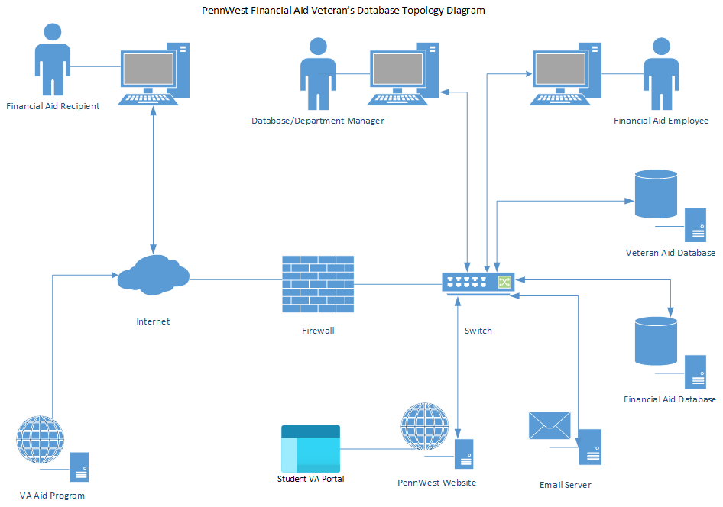

**Data Flow Diagrams**

**Context Diagram**



**Data Flow Diagram Level 1**



**Data Flow Diagram Level 2**









**Entity Relationship Diagram**



**Screen Sequence**

**Login**

**\*\*Login** - The user can enter their username and password, and then select “Login” to gain access to the home page.

**Index**

**\*\*Index/Home -** This page provides the user with options to search the database for specific students, add a new student record, run a report that filters the students in the database, and send a batch email to the entire database.

**Search**

**\*\*Search** – This page allows the user to search the student database with several parameters. The user can enter a first name and/or last name as a filter. They may also use the Student ID, and they may return a query with all uncertified students for the current semester.

**Search Results**

**\*\*Results –** This page displays the results from the prior search page. This will return records that include the Student ID, last name, first name, a Y or N response to certification for the current semester and the option to select all, one, or multiple returned results. Upon select, the user will be transferred to the email page.

**New Record**

**\*\*New Record –** This page allows the user to enter a student into the database. There are areas to put the student ID, first name, last name, address, phone number, and email.

**Student Record**

**\*\*Student record** – This page allows the user to view all student information.

**Email**

**\*\*Email** – This is the email page. The selected student(s) are displayed at the top, the template is selectable, the subject can be entered, and the body can be edited. The date to send can be scheduled for immediate dispatch or a later date.

**Report**

**\*\*Reports** – This is the page to generate reports. Start and end dates can be entered, certification status can be selected, and aid type can be selected. You can select “Generate Report” to view results immediately, “Email All Results” to directly proceed to the email form with the results, or “Print Report” for later viewing.

[Cite your source here.]

**Report Results**

**\*\*Report Results**- This page supplies the user with the results inside of the specified parameters. The report parameters are listed at the top and the results follow. The user has the option to send a batch email to all results or to print the report.

[Cite your source here.]

**Project Management Plan**